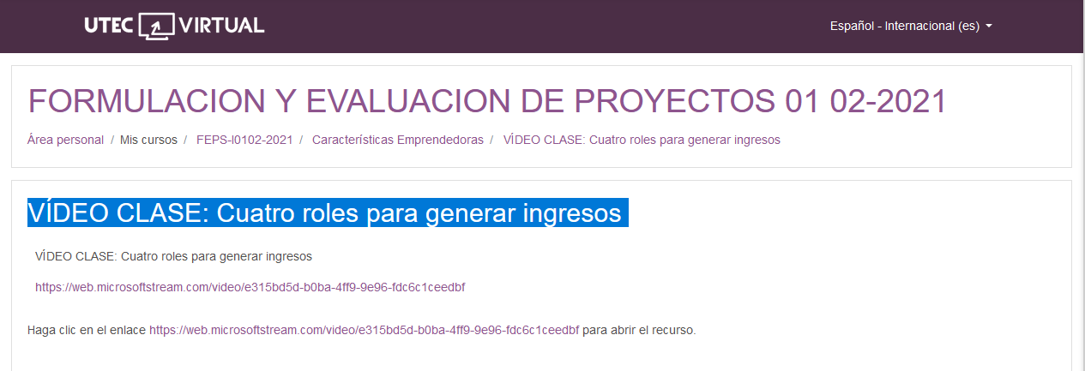

<https://web.microsoftstream.com/video/e315bd5d-b0ba-4ff9-9e96-fdc6c1ceedbf>

<https://web.microsoftstream.com/video/e315bd5d-b0ba-4ff9-9e96-fdc6c1ceedbf>